First make notepad file then named Hello.java

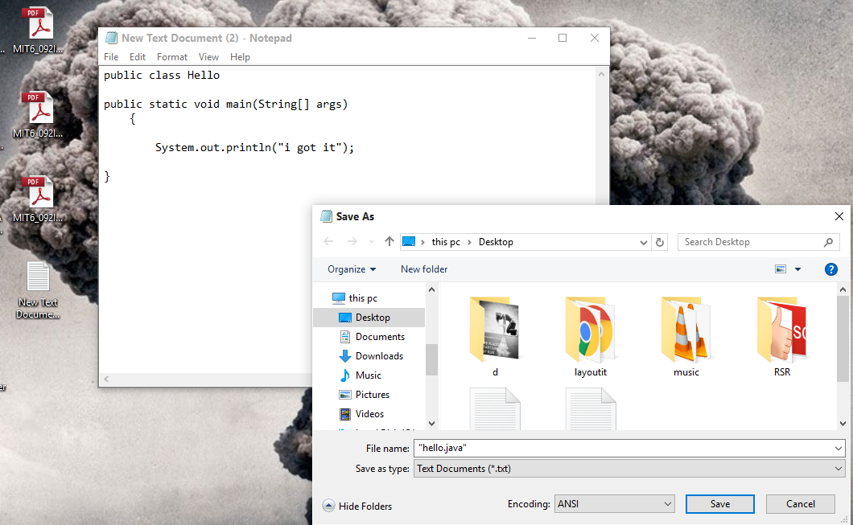

2.open cmd then enter the name of

\*“javac hello.java”.

\*”java Class name”

